**Working with Selenium Grid:**

**What is selenium Grid?**

Selenium Grid is used to run your automation tests on multiple platforms and browsers simoultaneously.

For example, if you have 1000 test cases and if execute all those 1000 test cases on one machine it will take a lot of time. But if you have 5 machines and if you can run those 1000 test cases on 5 different machines, 200 each on each system, then the time of execution will be reduced to almost 1/5th of the original time.

Selenium Grid enables you to run your automation test cases on different platforms and browsers parallelly.

**When to use Selenium Grid:**

Save time on execution: As mentioned above, if there are a number of test cases you have to execute and if you want to reduce the time of execution, you can use selenium Grid.

If you want to perform your testing on multiple platforms and multiple browsers, you can use selenium.

**Selenium Grid Architecture:**

Selenium Grid contains a hub and different nodes.

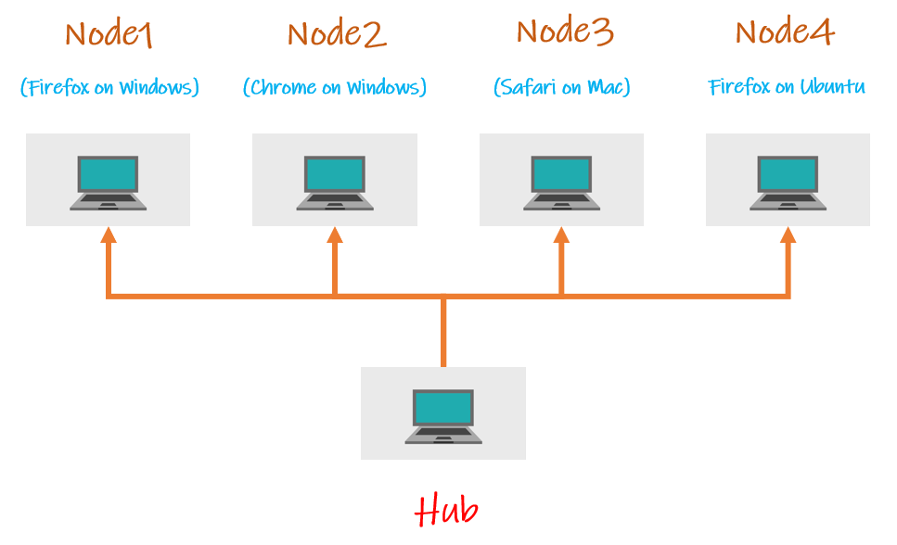

Hub:

* A hub is the central point where you load your tests into.
* There should be only one hub in a grid
* The hub will allocate the test cases based on the conditions mentioned and the automation will be done on the nodes.

Node:

* Nodes are the machines that you have allocated to the hub and the tests will be performed on the nodes.
* There can be one or more nodes in the grid.
* Nodes can be launched on multiple machines with different machines with different platforms and browsers.
* The machines running the nodes need not be the same platform as that of the hub.